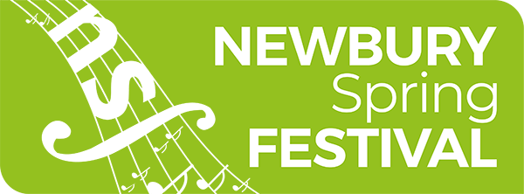
NSF Young Festival Critic Competition

Dear Parent / Guardian

This week in school, children have been exploring how to be a music critic and how to write a review of a concert. We have been using resources and videos that have been provided by Newbury Spring Festival which is an international music festival that takes place in May at various venues across Newbury and West Berkshire
There have been some fabulous reviews created at it has sparked some creative and imaginative writing.
If your child enjoyed becoming a music critic for the day, Newbury Spring Festival are running a Young Festival Critic Competition where participants get the chance to win a series of prizes including:
- meeting and interviewing one of next year’s Newbury Spring Festival artists;
- writing with the arts editor of Newbury Weekly News and having a review published;
- presenting a concert review live on Kennet Radio;
- free music lessons with Good Vibes Music Academy; and
- an invitation to the Newbury Spring Festival Gala Dinner to receive the award.
The competition is open to children and young people aged between 5 and 18. To enter, simply attend any of the Newbury Spring Festival’s events and write a review using their new-found skills! To help, most tickets for children are half price and there is even a ‘Free for Under 30s’ ticket scheme for selected events too.
Entries need to be submitted before 15 June 2024 and winners will be announced before the end of the summer term.

If you would like to take part in the competition, you can find more information and enter at https://www.newburyspringfestival.org.uk/about-us/yfc/

Kind Regards

[Teacher Name]
[School Name]

